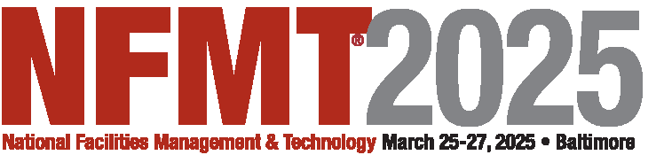**Baltimore Convention Center**

**Baltimore, MD EXHIBITOR APPOINTED CONTRACTOR (EAC)**

**NOTIFICATION FORM**

NFMT® has selected certain firms (at rates considered equitable and normal for the area) as Official Contractors for various convention services. If you, the exhibitor, have contracted with any firm other than those appointed by NFMT®, you must

complete and return this form. It is your responsibility to inform your contractor of the rules governing exhibitor appointed contractors. NOTE: There may be certain vendors & services exclusive to the Baltimore Convention Center and an EAC will not be allowed to provide that service.

**Deadline for Certificate of Insurance is Monday, February 24th .** EAC's are required to provide a certificate of insurance showing a minimum limit of $3,000,000.00 per occurrence for property damage, personal injury, workers compensation

aggregate coverage of $3,000,000.00 per occurrence, and naming the following as additionally insured for the dates of the event (including move in and out days):

Freeman / ROC Exhibitions, Inc. / The Mayor, The City of Baltimore, the Baltimore Convention Center, it’s employees, it’s elected/appointed officials, employees and official agents / Forum Media Group / Trade Press Media Group / and the

NFMT® Conference and Expo.

•The EAC must abide by the rules and regulations of the event and all pertinent union regulations.

•The EAC’s employees must wear approved identification badges at all times while in the work area.

•If the EAC is empowered to incur expense on behalf of the exhibitor, a *Third-Party Payment Authorization* form must be completed and returned to Freeman. The exhibitor agrees that they are ultimately responsible for the cost of all

services provided in connection to their exhibit space.

•The EAC agrees to have evidence, in the exhibit space, that it has a valid authorization from the Exhibitor for services.

•The EAC must confine its operations to the exhibit area of its clients. No service desks, storage areas or other work facilities will be located anywhere in the facility. Show aisles and public areas are not part of the Exhibitor’s exhibit

space.

•The EAC may not solicit business on the exhibit floor.

•The EAC must have all business licenses, work permits, and insurance required by State and City governments and Facility Management before beginning work and shall provide Event Management with evidence of compliance.

* If required, the EAC must be able to provide evidence that it has current and applicable labor contracts and must comply with all labor agreements and jurisdictions. The EAC must not jeopardize the production of the event by any act or practice that would lead to work stoppages, strikes or labor disputes.

Exhibiting Company: EAC Company:

Services Provided by EAC:

Exhibit Space #:

Address City/State/ Zip:

Contact:

Phone: Email:

Exhibitor Signature:

**E-mail to:** E-Mail: [nfmt@rocexhibitions.com](mailto:nfmt@rocexhibitions.com)

Date